**BruinRoute: Improving Access and Inclusion at UCLA**

Authors: Emma Chang, Isha Rajput, Stella Kang, Claudia Alvarez, Miranda Solorio

Table of Contents:

Page 1…. Literature Review

Page 6 …. Interviews with Stakeholders

Page 8 …. Ethnographic Observations

Page 10 …. Initial Plans for Usability Testing

Page … Script for Usability Evaluation

[Lo-fi design](https://www.figma.com/file/esjoUpnBylnjB8BmT4TnRY/Low-Fi-Wireframes%3A-BruinRoute-App?type=design&node-id=0%3A1&mode=design&t=dWgzMqZktle0sO5x-1)

[Hi-fi design](https://bruinroute.retool.com/mobile/apps/BruinRoute) (login required)

[Hi-fi design](https://drive.google.com/file/d/1F4jcT2Vd3R4PnbPKcclfyfMhSHTneHBx/view?usp=drive_link) (no login, video)

[Slides](https://docs.google.com/presentation/d/1KhX7p74sGhXJAI1YV2Yvwi0GsnH34tbaajKb_Frv7ec/edit?usp=sharing)

### **Enhancing Navigational Accessibility for Mobility-Impaired Individuals on the UCLA campus through BruinRoute: Literature Review**

This literature review explores the challenges faced by individuals with mobility impairments when navigating urban areas, particularly university campuses. It draws insights from three key studies and discusses the relevance of their findings to the development of the BruinRoute app, aimed at improving navigational accessibility on the UCLA campus.

The first study, "Personalized accessibility map (PAM): a novel assisted wayfinding approach for people with disabilities", explores the concept of Personalized Accessibility Maps (PAM), specifically to aid the mobility of students with disabilities on college campuses. It outlines optimal requirements for PAM, referencing existing literature, criteria used in geo-crowdsourcing services, and ADA standards. The study also introduces a prototype PAM developed for the University of Pittsburgh. The article states, "The current pedestrian navigation services for people with disabilities…are based on broad user groups needs and do not offer personalized solutions and utilize limited or subjective criteria in routing solutions" (Karimi et al. 2013). This explains the need for personalized solutions such as RouteChekr, which "integrates both active and passive data collection and includes a method for personalization based on predefined user group profiles that are adapted by users as they rate segments on a 5-point Likert scale" or PAM which is "oriented towards the creation of a base map of accessibility features and providing personalized routing solutions based on a sidewalk network" (Karimi et al. 2013).

PAM serves as a relevant concept for BruinRoute's development. By understanding the criteria and requirements laid out in this study, the app can be tailored to cater to the unique needs of students with disabilities at UCLA. For example, users can create personal profiles within the app, specifying their accessibility requirements, such as the type of mobility aid they use (e.g., wheelchair, crutches), preferences for accessible features (e.g., ramps, elevators), and any other specific needs. This is important since, as the study showed, recognizing that the needs and preferences of individuals with disabilities can vary significantly, so personal profiles can help in this case. Furthermore, The user profiles reflect a user-centric design approach, which is a recurring theme in the literature. By putting users in control of defining their accessibility requirements, the app aligns with the idea of empowering individuals with disabilities to make informed decisions about their routes and access to campus facilities.

The second study, "Mapping for Wheelchair Users: Route Navigation in Urban Spaces", highlights the limitations in urban navigation for individuals with mobility impairments, emphasizing the need for tailored accessibility maps. Researchers used questionnaires and conducted field surveys with wheelchair users to calculate the difficulty of maneuvering around certain features or barriers on the pedestrian routes. For instance, they quantified the difficulty of navigating various streets using the streets’ slope angles and surface type, and they also rated the level of difficulty presented by different dropped curbs. The researchers then created a GIS-based application that would calculate the “best”, or least difficult, route that a user could take to their chosen destination. Additionally, the interface gives users the option to view all wheelchair accessible routes that emanate from a specific location.

The methods of this study will be helpful in evaluating the accessibility of UCLA’s campus and for designing an app that allows users to customize their routes. The researchers used data from wheelchair users to identify features that make pedestrian routes less accessible, so we can examine whether these features are prominent on UCLA’s campus and determine whether they pose a similar amount of difficulty for UCLA students. Additionally, BruinRoute can incorporate GIS technology to create personalized accessibility maps for the UCLA campus, thereby helping wheelchair users identify accessible routes and obstacles more efficiently. For example, GIS can be used to create layers or overlays on the campus map to display various accessibility-related information, such as accessible pathways, wheelchair-friendly entrances, and accessible restrooms. The GIS system can also store and analyze crowdsourced data for updates and improvements, which ties in with BruinRoute's reporting feature.

The third study, "Evaluating Wheelchair-accessible design on College Campuses", addresses the impact of policies and standards for accessibility in public facilities on the quality of design and life for all individuals, including those with mobility impairments. The study evaluates wheelchair users' experiences in negotiating accessible design features on college campuses, assessing elements like elevators, doors, ramps, and curb ramps. This source underscores the critical need for ongoing evaluations of accessible design in response to policies aimed at enhancing the accessibility of public facilities. It begins by acknowledging the significant impact of policies like the Rehabilitation Act of 1973 and standards such as the American National Standard A.117.1 and the Uniform Federal Accessibility Standards. These policies have led to the development of comprehensive guidelines for accessible design, reflecting advances in the field.

This source goes on to highlight a key point: while guidelines have been developed based on extensive research in human factors engineering and handicapping conditions, the evaluation of design implementation in everyday use has been limited. This emphasizes a crucial gap in the process—moving from theoretical design standards to practical, everyday usability. Furthermore, the quote points out that the abilities and needs of individuals with handicapping conditions can vary greatly. This diversity, encompassing perceptual, cognitive, and motor abilities, isn't always fully addressed by existing standards. For example, a ramp that meets minimum standards may be suitable for some wheelchair users but not for others with varying levels of physical impairment. The source also acknowledges the importance of considering environmental design that caters to common physical limitations to provide a universally acceptable environment. In conclusion, this source highlights the necessity for continual evaluations of accessible design in real-world contexts, considering the diverse range of needs and abilities among individuals with handicapping conditions. These evaluations are crucial for ensuring that accessible design is not just compliant with standards but also genuinely usable and accommodating to a wide spectrum of disabilities.

This source enables the BruinRoute to offer personalized route recommendations and consider the diverse range of needs and abilities among its users. Furthermore, the study underscores that even environments designed for accessibility may still present practical challenges. This insight helps BruinRoute identify potential obstacles and provide alternative routes that navigate around these issues. Moreover, the article discusses design elements that enhance accessibility, such as minimizing slopes, providing handrails, and protecting ramps from weather conditions. BruinRoute can incorporate these design principles to offer smoother and more accessible routes. Lastly, recognizing that accessibility is not uniform, the study encourages the app to provide customization options, allowing users to specify their unique needs and preferences. This personalization makes BruinRoute more adaptable and user-centric, aligning closely with the real-world challenges faced by wheelchair users at UCLA.

Overall, the combined insights from these studies emphasize the significance of tailored accessibility solutions, the utilization of GIS technology, and the challenges and opportunities in enhancing navigational accessibility for individuals with mobility impairments. These insights are directly applicable to the development of the BruinRoute app, which aims to make the UCLA campus more accessible for all, particularly students with disabilities. As the article published by the Daily Bruin states, "Despite UCLA’s claims of being an accessible campus, its lackluster resources fall short" (2023). This emphasizes the urgency for improvements in accessibility and inclusion at UCLA, and the need for an app like BruinRoute. Through implementing these solutions, BruinRoute can offer a user-friendly and effective solution to improve navigational accessibility on the UCLA campus, creating a more inclusive and accessible university environment.

**References**

Beale, L., Field, K., Briggs, D., Picton, P., & Matthews, H. (2006). Mapping for wheelchair

users: Route navigation in Urban Spaces. *The Cartographic Journal*, *43*(1), 68–81.

https://doi.org/10.1179/000870406x93517

Editorial Board. (2023, January 26). *Editorial: UCLA’s lack of accessible structures does disservice to students with disabilities*. Daily Bruin. Retrieved October 29, 2023, from https://dailybruin.com/2023/01/26/editorial-uclas-lack-of-accessible-structures-does-disservice-to-students-with-disabilities

Karimi, H. A., Zhang, L., & Benner, J. G. (2014). Personalized accessibility map (PAM): A

Novel assisted Wayfinding Approach for people with disabilities. *Annals of GIS*, *20*(2),

99–108. https://doi.org/10.1080/19475683.2014.904438

Norris-Baker, C., & Stephens, M. A. P. (1987). Evaluating wheelchair-accessible design on

college campuses . *Journal of Architectural and Planning Research*, *4*(2), 149–161.

https://doi.org/http://www.jstor.org/stable/43029489

### **Interviews and Stakeholders**

To improve our understanding of the domain space, we will set up a time to interview Veronica Martinez-Lopez and Spencer Scruggs, the associate director and director of the UCLA Center for Accessible Education (CAE). We are hoping they will be able to provide some insight into their experiences, as well as any knowledge they might have about addressing accessibility and mobility challenges as it relates to wayfinding on UCLA’s campus. We will meet with them on zoom to conduct the interview. For the full interview, please see [this document](https://docs.google.com/document/d/1GIRtLZI_HBmyRAkcfaWLZnLfLysYpOGBPE__HxPRUrc/edit?usp=sharing).

Additionally, we are hoping to interview students from the UCLA Disabled Student Union (DSU). We will ask about their experiences with navigating campus, the routes they take, and any insights into ways in which our project might help in making navigating UCLA more accessible. Depending on the students’ availability, we will either meet with them in person or on zoom to conduct the interviews.

Finally, our project is leveraging 'Metamaps,' a platform known for providing accessibility routes to those who need them on UCLA's campus. We are reaching out to former staff members such as Carolanne Link who have experience with it for their insights and advice. We're currently in the process of creating a tool that emphasizes providing accessible routes, and this decision holds several key benefits. Consulting with previous staff members offers us valuable insights into the strengths, limitations, and potential of Metamaps in the context of accessibility on a university campus. Their expertise guides us in making informed decisions, saving us time and helping us steer clear of common pitfalls. Secondly, we're making the most of the capabilities and features that Metamaps has already demonstrated, particularly in serving the needs of individuals seeking accessible routes. This established tool accelerates our project's development process, and it aligns well with our goals. This not only saves us valuable resources but also ensures we continue to provide a valuable service for those who require accessible routes.

We are planning to ask the following questions:

1. Would you be able to provide an overview of the Center for Accessible Education Office's role and responsibilities on campus?
2. In your experience, what are some of the most common challenges or barriers that students with disabilities face in accessing university programs and facilities?
3. What advice or recommendations would you provide to a project aiming to improve accessibility on campus, such as the development of the BruinRoute app?
4. What specific programs, services, or facilities are most commonly addressed by your office in terms of accessibility for disabled individuals?
5. How do you gather feedback or input from disabled individuals or the broader campus community to inform your work and priorities?

For Students:

Name

Year

Housing

1. Can you describe what it was like navigating campus for the first time? Were there any issues you came across or a specific memory that stands out?
2. What does your route to class look like? To go home? To any of your weekly activities? (ex. clubs, grocery stores, etc.) Please specify if there are any stairs, elevators, or ramps that you use.
3. Can you share any insights about the physical accessibility of campus buildings and facilities? Are there areas that need improvement?
4. Can you talk about any instances where you felt that the campus could do more to improve accessibility and inclusivity? Any positive or negative experiences you can share?
5. Do you or have you ever used any maps to help you navigate campus? (specifically UCLA campus maps, ex. MetaMap)
6. Have you ever reported any accessibility issues? If so, how was the quality of their response? If possible, please describe the issue and process of reporting

For MetaMap Faculty and Staff:

1. What were the key user feedback and experiences with the previous version of Metamaps, and how can we address them to enhance the new platform?
2. In terms of providing accessible routes, what were some of the notable features or strategies employed in the previous version, and how can we improve upon them?
3. Are there any new technologies, tools, or frameworks that have emerged since the previous version of Metamaps, which we should consider incorporating for a more robust platform?
4. What were the design principles and user interface considerations that contributed to the success of Metamaps, and how can we optimize the user experience on the new platform?
5. Were there any partnerships or collaborations in the previous project that significantly contributed to its success, and how can we establish similar partnerships or leverage their networks for the new platform?

**Insights from Interviews**

Our interview with Veronica Martinez-Lopez and Spencer Scruggs illuminated various struggles that students face when navigating UCLA’s campus, and they also provided various suggestions for features that we should consider for our app and factors we should take into account. They explained that some students with mobility issues have difficulty with navigating the hilly campus, getting through doorways, and finding accessible parking. Additionally, they emphasized the importance of understanding that definitions of accessibility are constantly changing, and that accessibility looks different depending on specific circumstances. For instance, a pathway that does not have stairs may not necessarily be accessible if the slope of the ramp is too high or if it depends on unreliable elevators as fundamental parts of its path. Furthermore, they suggested that we could expand the functionality of our app by implementing AI and VR. For example, students with limited vision could use a live VR interface that describes their immediate surroundings so that they can more easily navigate UCLA’s campus.

Our interviews with students from the DSU and Carolanne Link will take place in the near future. Once these interviews are complete, we will describe any insights we have gained from them and explain how they may be valuable to our project.

### **Ethnographic observations**

Accessibility Routes on campus have been reoriented to allow for seismic upgrades of Powell Library. The ongoing reconstruction of this area and the removal of key accessibility routes have prolonged the amount of time it would usually take to navigate toward central campus. As of now the accessibility routes to move towards central campus require you to go around the Tongva Steps area rather than through it. These accessibility routes are steeper and more difficult to navigate even for able-bodied students. Not to mention, these routes are now being more frequently used by students on electric scooters making traffic through these routes more complicated and disrupted. When navigating towards central campus you can navigate on either side of the Tongva Steps area, but regardless both paths require more navigation than the previous paths. Being able to know the most accessible and quickest routes to class even with ongoing construction can be incredibly useful to all students especially in cases where rerouting needs to occur. Currently the access map doesn’t update paths when accessibility routes are blocked off and when observing routes on campus this week more accessibility routes became closed off around Powell/Royce for Parent’s weekend. All in all a more dynamic system of mapping seems necessary here.

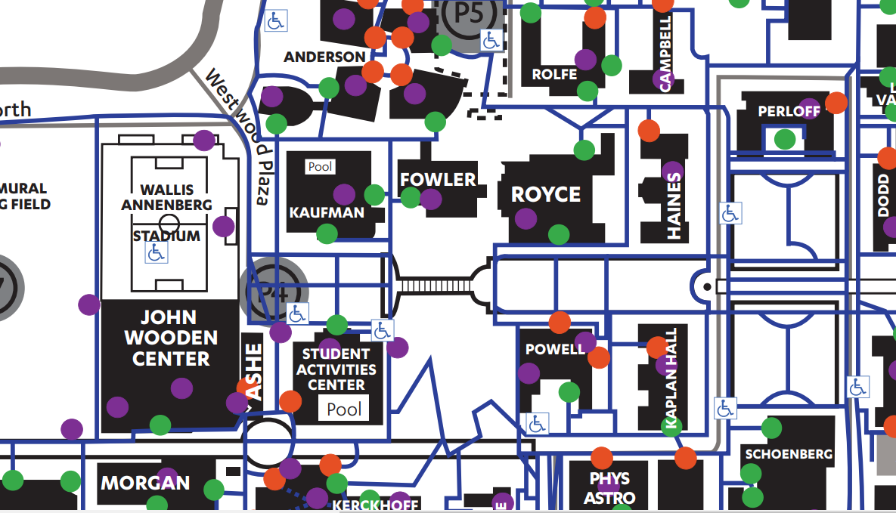

Another issue I noticed as I explored some of the accessible facilities on campus was the difference in the water fountain options offered on campus. In the building with the CAE office, we noticed that the water fountain was lower which allows easier access to individuals with disabilities. However, typical water fountains around campus have the actual fountain placed much higher, which is not very accessible. Highlighting the more accessible facilities would be useful on the app, as well as a call for more like this.

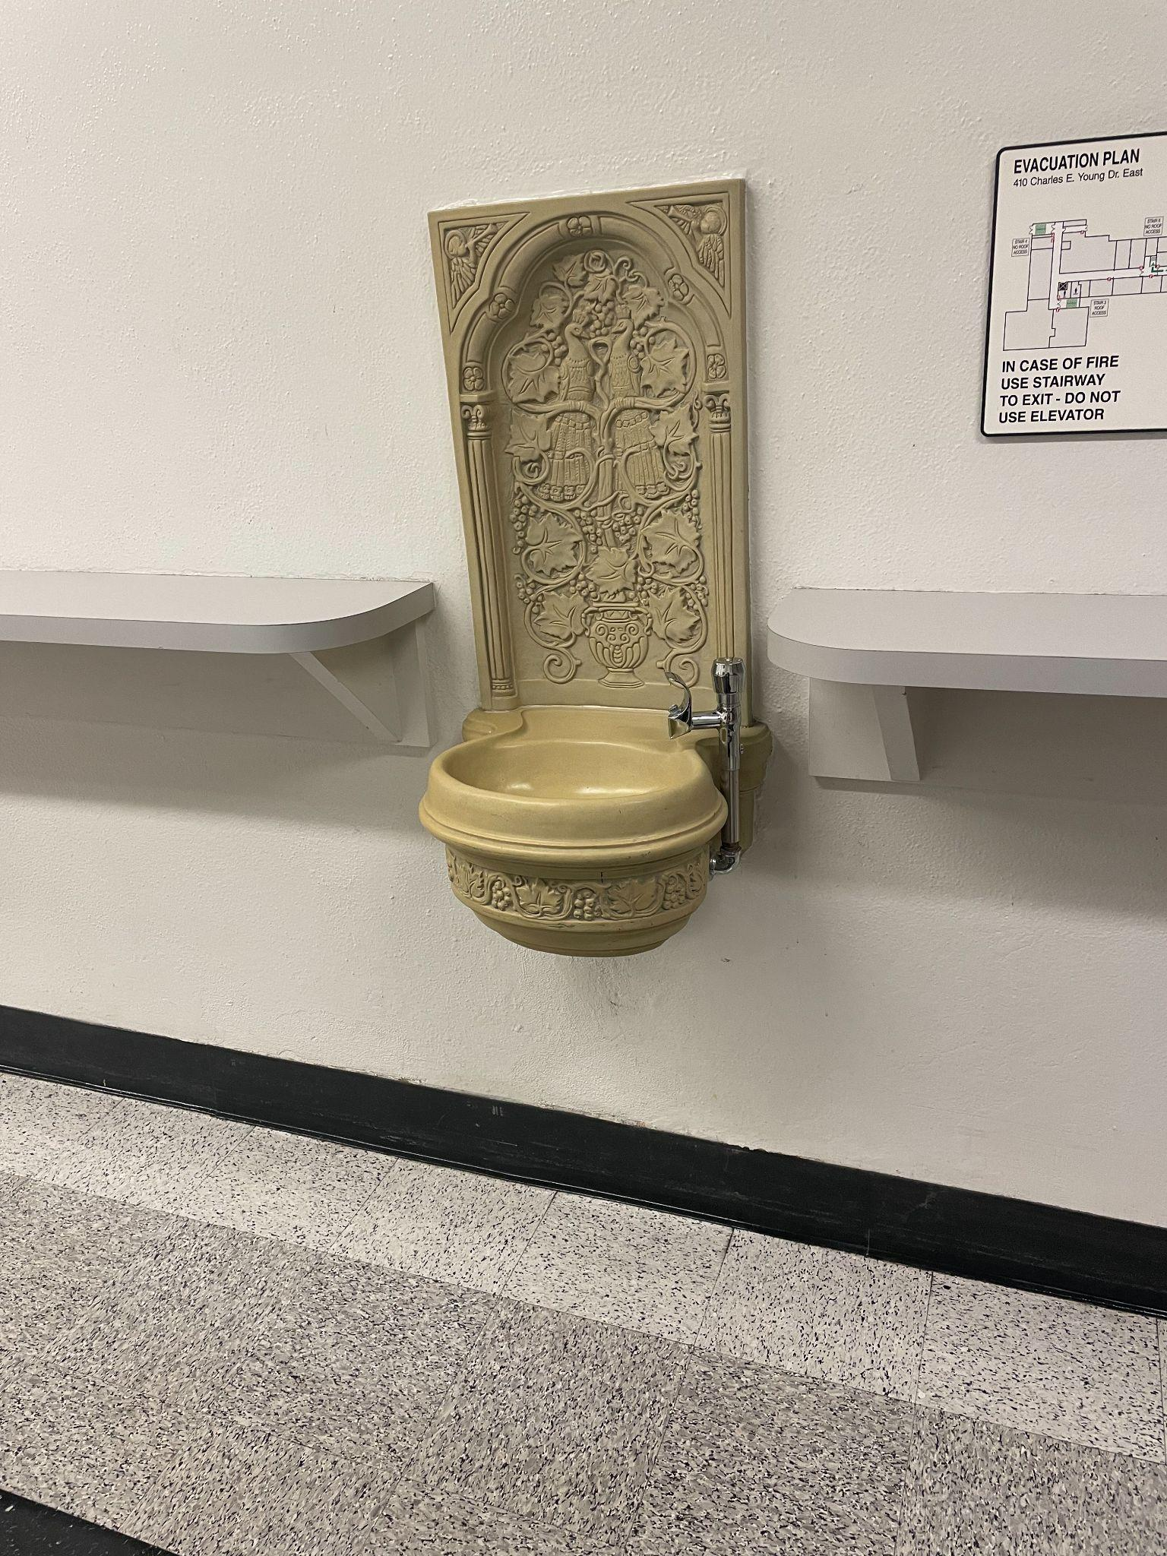

Route wise, I noticed that around Rolfe, the area is surrounded by stairs. Getting to the second level to Northern Lights and other buildings around there would require knowing about elevators in the building prior to reaching those points. In this way, it would be helpful for the app to point out elevators that take you to this place through current buildings on campus.

Another aspect of difficulty in terms of navigation, is the issue of elevators here on campus. I work within Bunche Hall and elevators are constantly broken but the building itself is difficult to navigate without elevators. In cases where only one elevator is working, traffic in and out of the building is prolonged. That was the case for me where I found myself waiting longer than ten minutes to get an elevator that would take me to the second floor for my class. Having some sort of system that alerts students to elevator issues on campus can be exceedingly helpful.

### **Initial Plans for Usability Testing**

In order to prepare for the collection user feedback, we will start by defining the objectives of the collection, identify the targeted users with user personas, and finally select the method of collecting the user feedback. The objective of the app is to map out routes for UCLA students that are accessible, and our target users are UCLA students who seeking a tool that can help them navigate accessible routes on campus. In the case that the user feedback is through a survey, we will design a survey that delves into different facets of BruinRoute’s front-end web implementation. This will help us understand user experiences and preferences comprehensively. In our survey, we may ask different types of questions such as open-ended questions that can help direct users into giving feedback that is specific to their experience with the front-end web implementation. In these questions, we would ask questions that would allow users to reflect on the success rate of achieving their goals with BruinRoute and the insights the individual insights they could give in improving BruinRoute. In addition, BruinRoute also has a “Report” page that will allow users to report inaccurate routes, which is equivalent to an in-app feedback form.

On our survey, we may ask users questions such as the following:

1. How many times did BruinRoute succeed in helping you plan accessible routes compared to the times it neglected to do so? How responsive was the app?
2. Thinking about the overall design and layout of BruinRoute, are there any suggestions you have for enhancing the visual aspects or making the interface more intuitive for users?
3. In terms of accessibility features, how well do you think BruinRoute caters to different user needs? Are there specific accessibility features you would like to see added or improved?
4. In your opinion, what are the key strength of BruinRoute in assisting with accessible route planning? Are there specific features or design elements that you found beneficial?
5. Considering your experiences with BruinRoute, what advice would you give to a friend who also wants to use BruinRoute to have a better experience?
6. Reflecting on you experience with other navigation apps, how does BruinRoute compare in terms of usability and effectiveness for navigating UCLA campus?

After the method of collecting the user feedback is finalized, we will begin usability testing by recruiting participants representative of our target users. After recruiting UCLA students seeking accessible routes on campus, we can focus on developing realistic scenarios for our participants to complete, which address core functionalities of the web application. While our participants are using the app, these experiences can allow users to collect observations they noticed while testing the app. These observations would be based on how users interact with the app to identify usability issues, navigation challenges, as well as positive interactions with certain features. Following the collection of user feedback, we would conduct feedback analysis, which allows us to derive insights and common themes related to the potential usability of the app. To organize these qualitative and quantitative insights, we would report these patterns in an summary of the findings, prioritized recommendations based on user feedback that can be implemented, and a detailed analysis of the feedback based on usability, features and design. Following the analysis of the user feedback, we would conduct follow-up testing to after implementing the recommended changes based on the user feedback.

### 

### Usability Plan/Description

Based on the feedback given during our class presentation we understand there are concerns about certain features such as how elevator reports can be shown on the map and how frequently would users realistically turn to our interface for navigation if a route is memorized after first use. Our usability testing will give us a stronger idea of how these concerns will come across to the population in need of this application. Based on feedback through these interviews we plan to further our quest in deciding which features will be in the final project and which will not. We also may be forced to consider different environments for this project outside of just a phone application based on interviews. Our goal is to identify which aspects of our project are the most necessary for a final product, as well as how easily our application can be navigated. There is strong interest in how our data can be applied to a greater project outside of this class to ensure that student’s accessibility needs are addressed through navigation tools, we hope that our usability testing along with our other data can continue to clarify the best way translate these needs to an intuitive user interface.

For recruitment, we'll primarily reach out to members of the Disabled Students Union (DSU) at UCLA, aiming to include students who are actively involved in campus accessibility initiatives. Additionally, we might employ a word-of-mouth approach to expand our reach, encouraging those with mobility impairments or disabilities who have experience navigating the UCLA campus to participate in these sessions. This mix of participants from DSU and others from the broader community ensures a diverse range of perspectives and experiences, offering comprehensive feedback for the improvement of BruinRoute. We hope to recruit 5 to 10 participants who have varying levels of familiarity with the UCLA campus. We have booked Sproul Study Room 110C (max 4 people) on Thursday, November 30 from 4:00 PM to 6:00 PM, but will offer Zoom which is a more accessible option for our users.

### Interview Script for BruinRoute Usability Evaluation

**Introduction**:

"Thank you for participating in this usability evaluation for BruinRoute. BruinRoute is an app designed to enhance navigation and accessibility for individuals with disabilities on the UCLA campus. This evaluation will help us gather valuable feedback from users like you to refine the app's functionalities and ensure it meets the diverse needs of our community.

The purpose of BruinRoute is to empower users, especially those with mobility challenges, by providing an intuitive and personalized navigation system across the UCLA campus. This app allows easier access to classes, facilities, and essential areas by offering accessible routes, identifying elevators, highlighting barrier-free pathways, and enabling real-time reporting of broken routes.

Before we proceed, I want to confirm if it's okay to record our session today. The recording will help us improve the app. We'll use the recording to better understand your experience and improve the app's usability. Does that sound okay to you?"

1. **User Background:**

For both in-person and Zoom: Can you briefly describe your familiarity with UCLA's campus and your experience with navigating it?

1. **BruinRoute Usage:**

For both in-person and Zoom: Have you used navigation or mapping apps before? If yes, which ones and what features did you find most useful?

1. **Feature Interaction:**

In-Person: We'll be sharing a static image of the app's interface. Could you please walk us through your typical interaction with the features shown?

Click here for follow-up prompts based on the user's responses.

Zoom: Since we can't interact directly with the app, I'll share my screen with the features. How do you envision using these features based on the screens displayed here (Show mobile app hi-fi design, ask users what to click on the screen so they can explore interacting with the app virtually)?

1. **Accessibility Preferences:**

For both in-person and Zoom: How effective do you think the customization options for accessibility preferences are?

Probe further to understand any preferences the user might have or features they'd want to customize. Click here for follow-up prompts based on the user's responses.

1. **Navigation Experience:**

For both in-person and Zoom: Imagine you're using BruinRoute to find your next class. What are your steps, and what do you expect from the app in this situation?

Explore their expectations and possible challenges they foresee.

1. **Reporting Functionality:**

For both in-person and Zoom: Let's discuss the process of reporting issues. How do you envision using the reporting feature based on its description?

Probe for any difficulties or suggestions in the reporting process. Click here for follow-up prompts based on the user's responses.

1. **Usability and Clarity:**

For both in-person and Zoom: Based on the features discussed, what's your overall impression of BruinRoute's usability?

We will encourage the user to rate the app's usability on a scale from 1-10 and express any concerns they have.

1. **Feedback and Improvement:**

For both in-person and Zoom: Can you suggest any additional functionalities or improvements that you believe would enhance BruinRoute's usability?

Click here for follow-up prompts based on the user's responses.

Open the floor for suggestions or specific features the user would like to see.

1. **General Feedback:**

For both in-person and Zoom: Any final comments or observations you'd like to share about your experience using BruinRoute?

We will allow the user to express any thoughts or feedback not covered by previous questions.

1. **Conclusion:**

For both in-person and Zoom: Thank the participant for their time and valuable input.

"Thank you for your participation in the usability evaluation of BruinRoute. Your insights, experiences, and feedback are incredibly important in developing and designing this app so we can better serve the needs of individuals with mobility impairments at UCLA.

#### Follow-up prompts based on the user's responses.

* Positive Feedback on Features:
  + Great, what about that feature did you find particularly useful?
  + Could you share an instance when this feature would be especially beneficial to you?
* Concerns or Difficulties:
  + Can you explain more about the specific issues you faced?
  + How do you think this feature could be improved to better meet your needs?
* Suggestions for Customization:
  + Are there preferences or customizations you'd like to see available?
  + Could you elaborate on any specific settings you'd find helpful or necessary for your navigation needs?
* Expectations from the App:
  + What additional functionalities do you think would complement these steps?
  + Is there anything specific you'd like the app to provide to make your navigation more seamless?
* Reporting Issues:
  + I see. How do you think this reporting process could be streamlined or made more user-friendly?
  + Can you describe a scenario where you might encounter difficulties using this reporting feature?
* Overall Impression on Usability:
  + Are there certain areas of the app that you find more or less user-friendly?
  + If you were to suggest an immediate change to enhance usability, what would it be?
* Feature Suggestions:
  + Can you detail how you envision using this proposed feature within BruinRoute?
  + Are there any specific functionalities you believe could significantly improve the app's usability for users like yourself?
* General Comments:
  + That's an interesting point. Could you elaborate more on your experience or offer additional suggestions based on it?
  + Is there anything else you feel we should consider when designing the app for better usability?

### User Feedback and Design Revisions

### **Feedback from Usability Testing**

One feature that the participants found to be particularly useful was the reporting feature. The students said that they often plan their routes ahead of time, but they would be frustrated when a blocked ramp or a broken elevator would force them to change plans. Additionally, they expressed interest in getting notifications when other students submit reports in the reporting feature. If these notifications could be sent out through the app, students could adjust their routes ahead of time, rather than having to redirect their path when they encounter an obstacle.

Another feature that the participants found useful was the static routes features, which emphasized the frustration of encountering unexpected barriers like blocked ramps or malfunctioning elevators, often disrupting carefully planned routes. For instance, popular paths such as navigating from Hedrick to Sproul, reaching Powell Library, or accessing the Court of Sciences were frequently mentioned. Incorporating these routes would significantly enhance the user experience, providing tailored solutions for the daily journeys of the student community. By incorporating these additional static routes and integrating notification functionalities within the reporting feature, the platform can offer a comprehensive solution to preemptively address obstacles and streamline navigation for its users.

In our user feedback, we also found the inclusion of a distinctive icon denoting these reported issues on the navigation interface particularly useful. This icon would serve as a visual indicator, enabling users to swiftly identify areas requiring route adjustments without delving into detailed reports. The significance of this proposed feature lies in its ability to provide users with at-a-glance information, allowing them to preemptively plan alternative routes. By quickly recognizing marked areas, users can efficiently navigate around impediments, optimizing their journey and avoiding unnecessary disruptions. Integrating this visual cue, such as an easily recognizable icon for reported issues, enhances the platform's usability, ensuring a more seamless and efficient navigation experience for all users.

**Design Revisions**

Upon further analysis of user habits and commonly traveled paths, it's evident that there's a need to expand the selection of static routes available within the system. Gathering insights from user behavior and preferences, consider including routes frequently used by students. This could encompass paths leading to key academic buildings, popular hangout spots, or common transit points. The aim is to provide a comprehensive selection of predefined routes that cater to various user needs and destinations. In addition, the development of the texting feature within the platform is a significant enhancement requested by users. This feature could facilitate seamless communication among users regarding route changes, real-time updates on reported issues, and the exchange of navigation tips or suggestions. Consider integrating a messaging system that maintains user privacy and focuses on facilitating constructive communication related to navigation and obstacle updates. This would empower users to collaborate, share information, and collectively contribute to a more efficient and user-friendly navigation experience.